Installing Rapport

Contents

1 Introduction 1

1.1 License 1

2 PHP for windows 2

2.1 downloading 2

2.2 Installing 2

2.3 Configuring 2

2.3.1 Create a SSL certificate 3

2.3.2 Change the SSL port 3

2.3.3 Select the PHP version 3

2.4 Add a link to https page 3

2.5 Starting the web server 3

3 3rd party libraries 4

# Introduction

Rapport provides at-a-glance information about your AppDynamics™. It is an open source, lightweight, coded entirely in PHP and JavaScript, web application.

This document describes how to install Rapport on your own windows desktop. However it can be deployed anywhere where you can run a PHP server.

## License

Rapport is copyrighted by sunil at [chickenkatsu.co.uk](https://www.chickenkatsu.co.uk) and licensed under the terms of the [Creative Commons Attribution-NonCommercial-NoDerivatives 4.0 International License](http://creativecommons.org/licenses/by-nc-nd/4.0/legalcode).

# PHP for windows

## downloading

I use the lightweight [Uniform Zero XIV](https://www.uniformserver.com/) LAMP distribution - self extracting zip files can be downloaded at [sourceforge](https://sourceforge.net/projects/miniserver/files/)

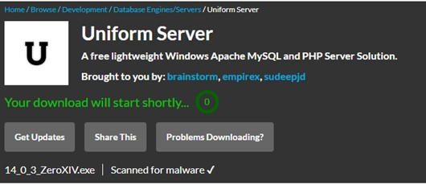

Always use a virus checker to confirm that downloaded files are safe.

## Installing

The downloaded file is a self-extracting zip file that runs as a portable application (ie it doesn’t require any installation, just unpack and go) . You can extract it yourself into the directory that you want uniserver to run from.

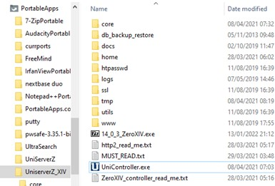

Please also download Visual C++ Redistributable for Visual Studio 2019 as noted in the file MUST_READ.txt from

**It can be downloaded from:**

**https://docs.microsoft.com/en-US/cpp/windows/latest-supported-vc-redist?view=msvc-170#visual-studio-2015-2017-2019-and-2022**

**Select: vc_redist.x86.exe**

## Configuring

Uniform zero is designed to run with minimal configuration. There are some things we need to do from the uniserver console.

Optional: In my version of uniserver I disable mysql support by deleting the folder core/mysql

Start the console: by running UniController.exe

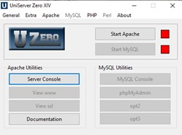

### Create a SSL certificate

Rapport runs on the cloud as https, even the on the development environment you must run https.

Luckily this is super easy on uniserver using the server cert and key generator

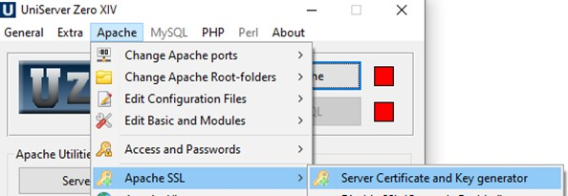

### Change the SSL port

Port 443 is usually privileged – best to change the port to 8443

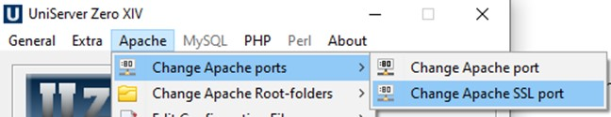

### Select the PHP version

Without this when you run apache, PHP wont run

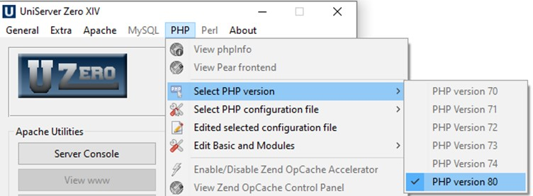

## Create a rapport subfolder

Under the uniserver ssl/ folder create a new folder called rapport

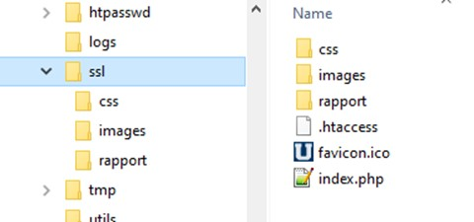

phpinc

## Add a link to https page

At startup Uniserver shows the pages served by http server, not by the https server. So go and edit www/index.php to add the https served pages

<h2>Server links</h2>

…

<p><a href="https://localhost:8443/rapport/">Rapport</a>

## Starting the web server

This couldn’t be simpler – just click the start apache button

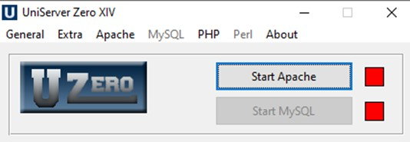

This will launch a web browser

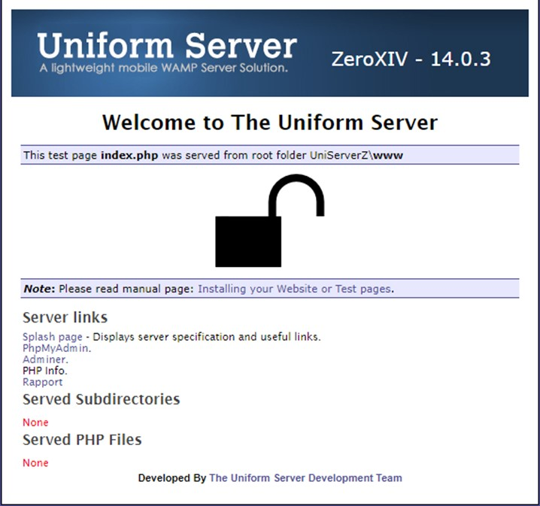

We’re not quite ready to click the rapport button yet 😉

# Site pages

The site needs a number of subdirectories:

* appdinc – php classes to interrogate the AppDynamics ®™ APIs
* phpinc – useful PHP functions
* jsinc – useful javascript functions
* rapport – the rapport web application

you will also need something to be able to clone github repos. I recommend using [github desktop](https://desktop.github.com/) for developing. But if you just want to download just use a web browser

## phpinc

clone the repository from [https://github.com/open768/phpinc/](https://github.com/open768/phpinc/archive/refs/heads/master.zip)

### phpinc/appd

clone the repository from <https://github.com/open768/appdinc>

### phpinc/extra/php-openssl-crypt

clone cryptor.php from https://github.com/ioncube/php-openssl-cryptor/tree/master/src

## jsinc

clone the repository from <https://github.com/open768/jsinc>

### jsinc/extra dependencies

|  |  |
| --- | --- |
| File | source |
| jquery/jquery-3.2.1.min.js | https://jquery.com/download/ |
| jquery-ui/jquery-ui.min.js | https://jqueryui.com/download/ |
| tablesorter/jquery.tablesorter.min.js | <https://github.com/christianbach/tablesorter> |
| jquery-inview/jquery.inview.min.js | <https://github.com/protonet/jquery.inview> |
| jquery-visible/jquery.visible.min.js | https://github.com/customd/jquery-visible |
| jquery-spinner/g-spinner.min.js | https://github.com/ceckenrode/g-spinner/tree/master/src |
| jquery-qtip/jquery.qtip.min.js | <https://github.com/salesagility/SuiteCRM/tree/master/include/javascript/qtip> |
| jquery-mdl-dialog/mdl-jquery-modal-dialog.js | https://github.com/oRRs/mdl-jquery-modal-dialog/blob/master |
| jquery-flowtype/flowtype.js | https://github.com/simplefocus/FlowType.JS/ |
| bean/bean.js | https://github.com/fat/bean |

## rapport

clone the repository from <https://github.com/open768/rapport>

## you’re all set

with all these files in place you are now set top start the site